A New Cadet’s Guide to eServices

What is eServices?
EServices is the most useful website a Civil Air Patrol cadet has access to. It is the gateway to all of the online cadet material -- ranging from cadet online testing all the way to scholarship applications. There are many amazing features of eServices that are not in this guide, so new cadets are highly encouraged to explore the website and discover all of its features.

Accessing eServices
Once you become a member of Civil Air Patrol, you have two ways to access eServices.
- Going to https://www.capnhq.gov/
- Searching “CAP eServices” on the search engine of your choice, and selecting the first option
If you are accessing eServices for the first time, select “click here to register”. You will be guided through the registration process. If you have already registered, you can sign in using your CAPID or username. Once signed in, you will see a screen that looks like this:

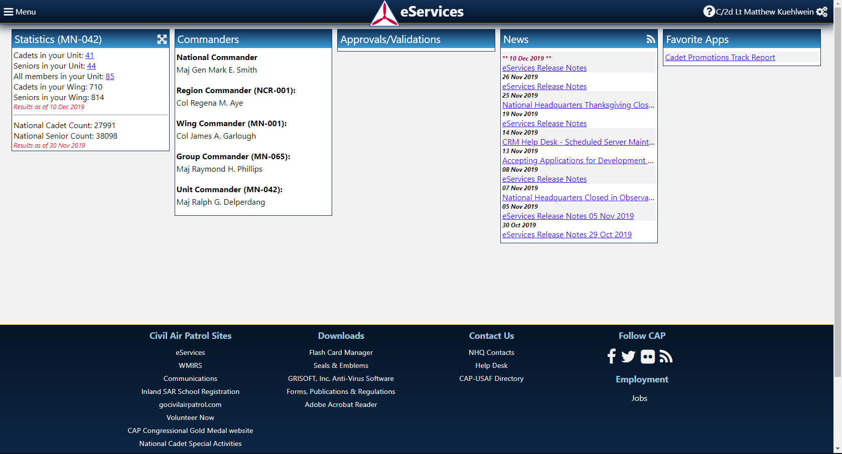

Accessing Online Testing
Now that you have signed in, it is time for you to learn how to take online promotion tests. For your first promotion, you are only required to take an open book leadership test. For all subsequent promotions, you will have to take both a leadership test and an aerospace test. To access the online testing section of eServices, click the “Menu” button on the top left of your screen. From there, select “Cadet Programs” -- the third tab from the top. In the new drop-down menu, select “Cadet Online Testing” -- once again the third option from the top.

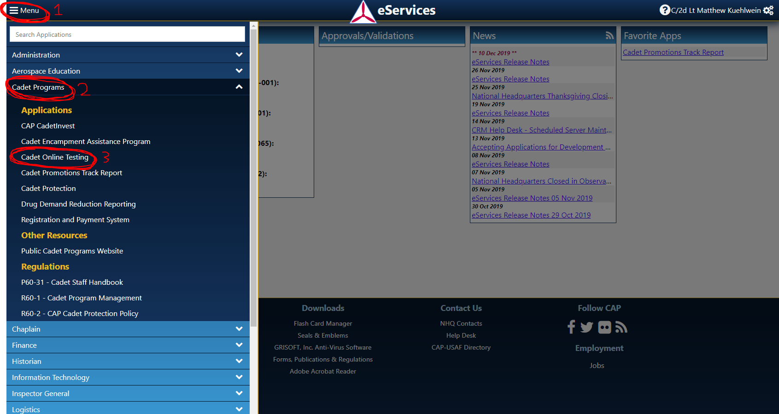

You will then be taken to a new screen. On the left-hand side, all of your different test categories will be visible. Your leadership tests are located under “Leadership Tests”, and your aerospace tests will be located under “Aero Dimensions Tests”. You may see multiple aerospace tests available to you -- you may choose to do them in any order. But remember: For your first promotion, you do NOT need to take an aerospace test. To begin the test, simply select the highlighted test name. But before you begin, you are highly recommended to read the material first.
Accessing The Leadership Online Textbook
It can take multiple weeks for your physical textbooks to arrive -- or perhaps you do not have them with you at the time. Either way, this should not be the reason that you are unable to take an online test -- all the textbooks can be found online! To access these textbooks, go to https://www.gocivilairpatrol.com/. From there, select the “Programs” tab. A drop-down menu will appear -- select “Cadet Programs” from the list. Another menu will appear, and this time you will need to select “Cadet Library” (the fourth option from the top).

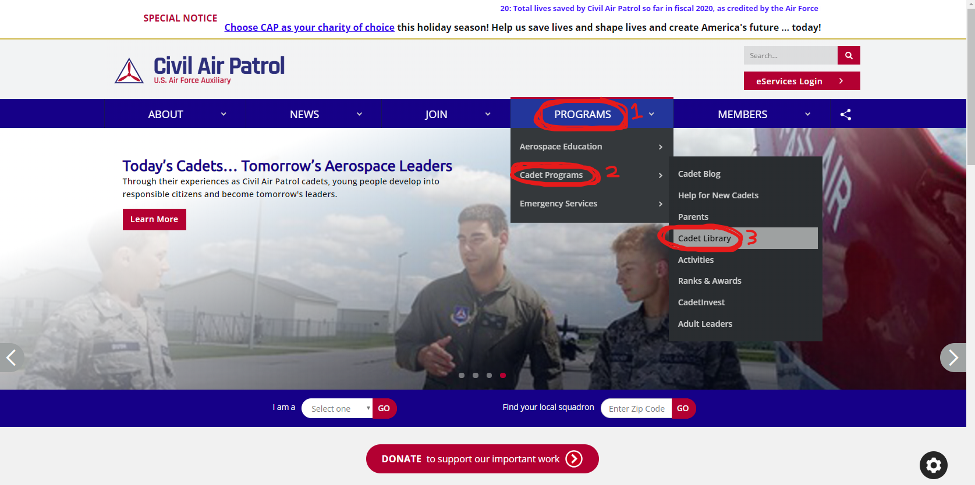

A new page will appear. Scroll about halfway down the page and you will see the “Leadership” category. Select “Learn to Lead” (the first option), and you will be taken to a page that contains the entire online textbook. Above the “Leadership” category is the “Orientation” category. Although it is not covered in this guide, the “Orientation” category contains very useful content that all new cadets should read. Happy studying!
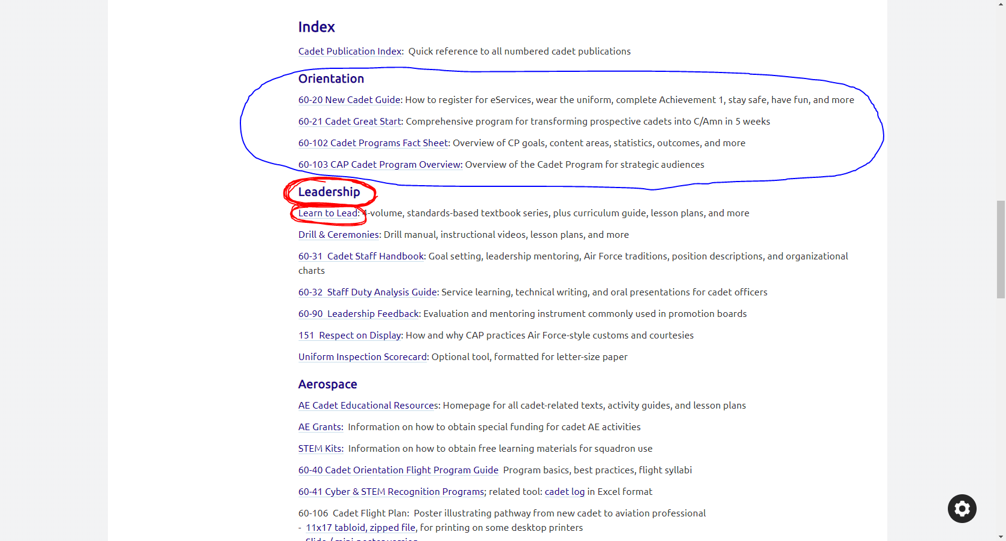

Accessing The Aerospace Online Textbook
Once you have completed your first promotion, you need to complete both a leadership and aerospace test. The online aerospace textbook is not found in the same place that the leadership textbook is. From the eServices home screen, click the “Menu” button located in the top left. From there, select “Aerospace Education” (the second option from the top). A dropdown menu will appear -- select “AE Downloads and Resources” (the section option from the top).

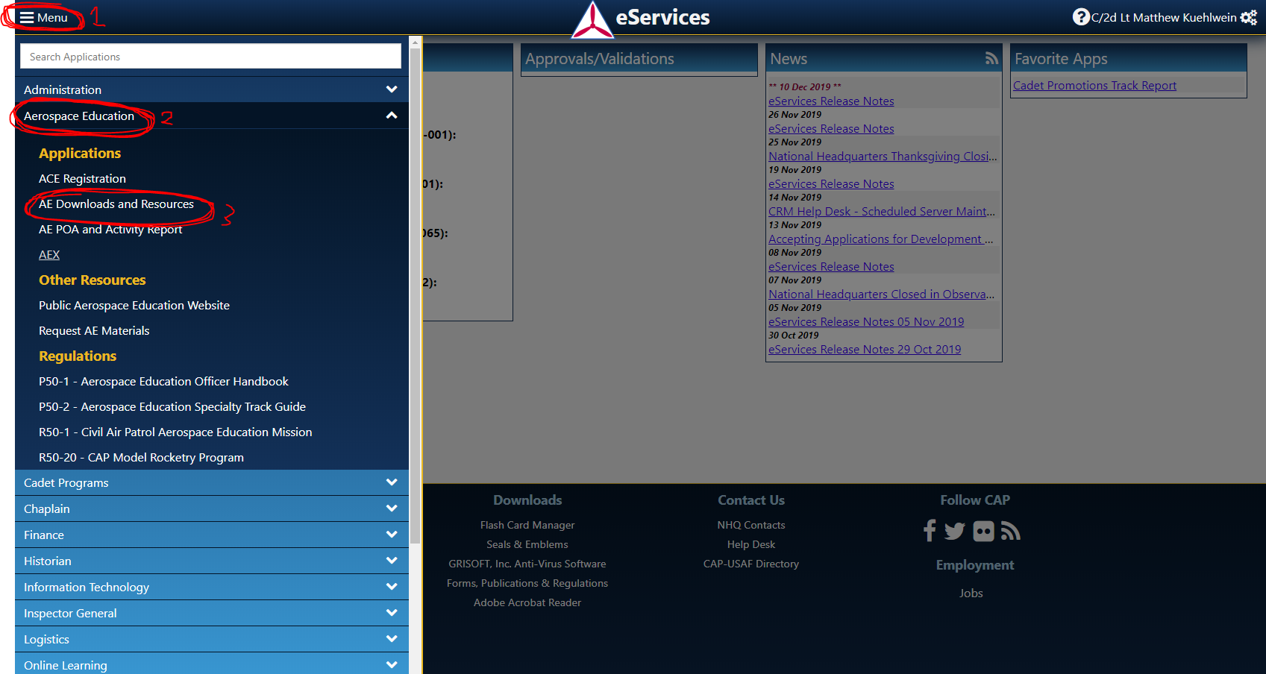

From the new screen, select the “Aerospace Dimensions Modules 3rd Edition”. From here you can access every aerospace module in the textbook. Happy studying!

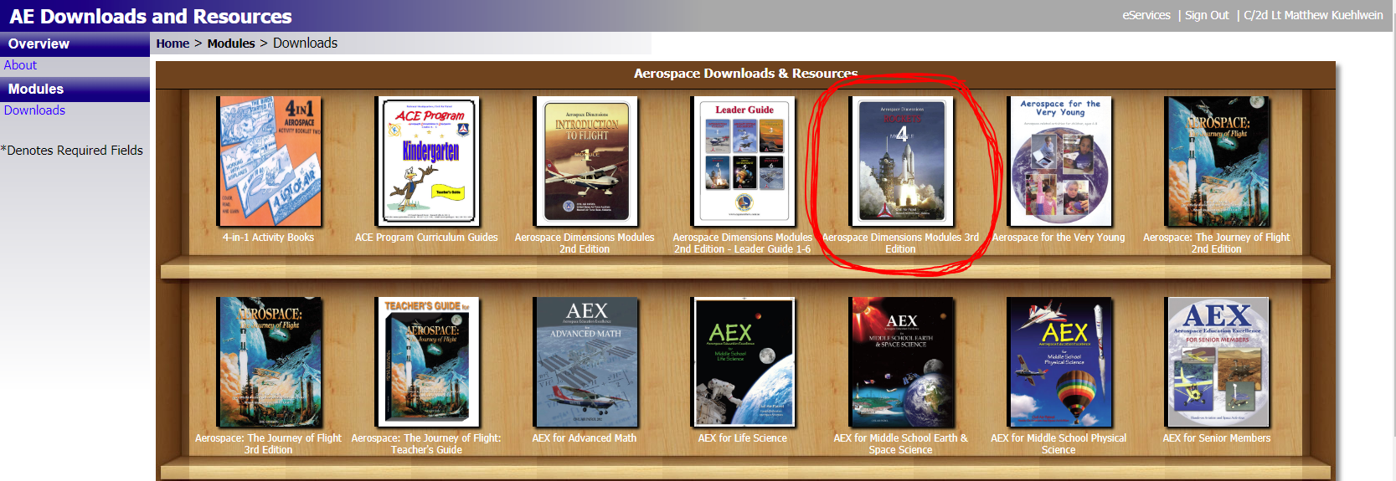

Accessing The Cadet Promotions Track Report
Another extremely useful tool that eServices offers is the ability to see your progress towards your next promotion. From the eServices home screen, click the “Menu” button on the top left of your screen. From there, select “Cadet Programs” -- the third tab from the top. In the new drop-down menu, select “Cadet Promotions Track Report”, which is the fourth option from the top.
